Course Management System

Core features:

* Course Management (add, edit, delete courses)
* Student Management (enrollment, records, grades)
* Faculty Management (assignments, course loads)
* Basic Authentication System
* Grade Recording and Computation
* Reporting System (grades, class lists, faculty loads)

Project Structure

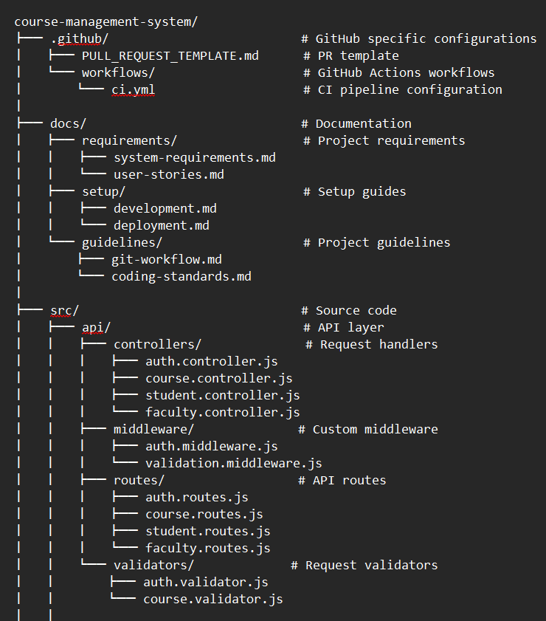

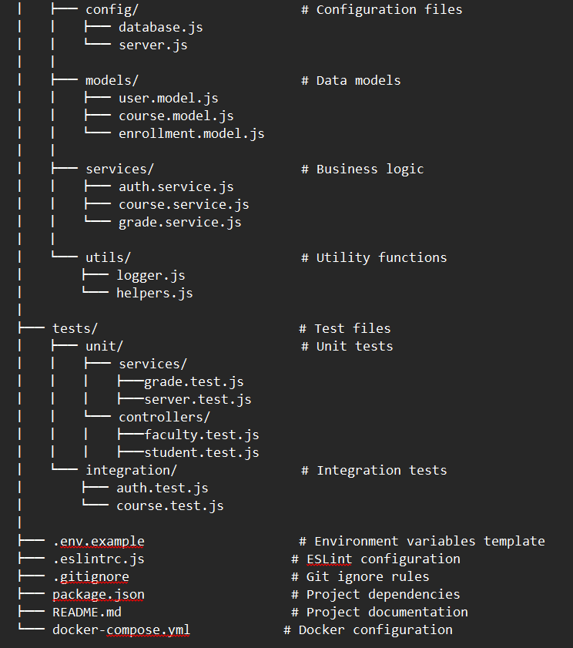

First commit in the master branch

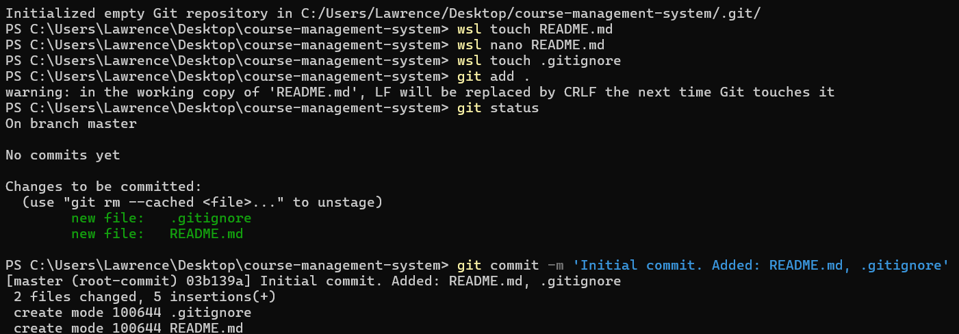

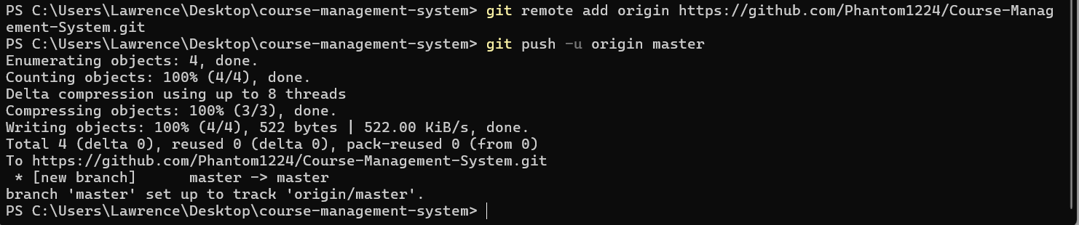

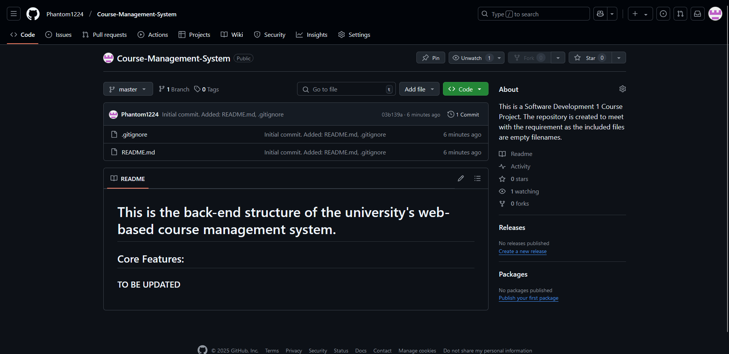

First initial issues

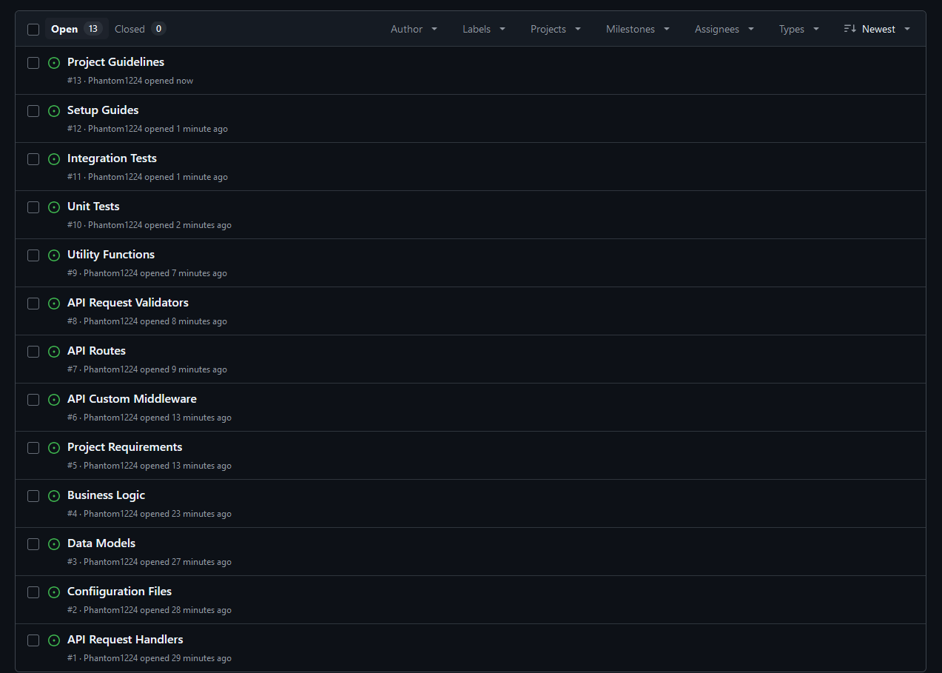

Finished api-request-handlers branch

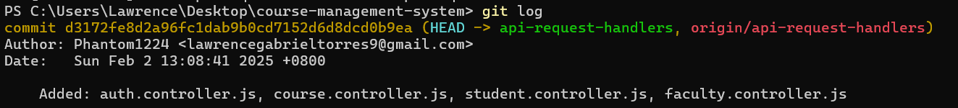

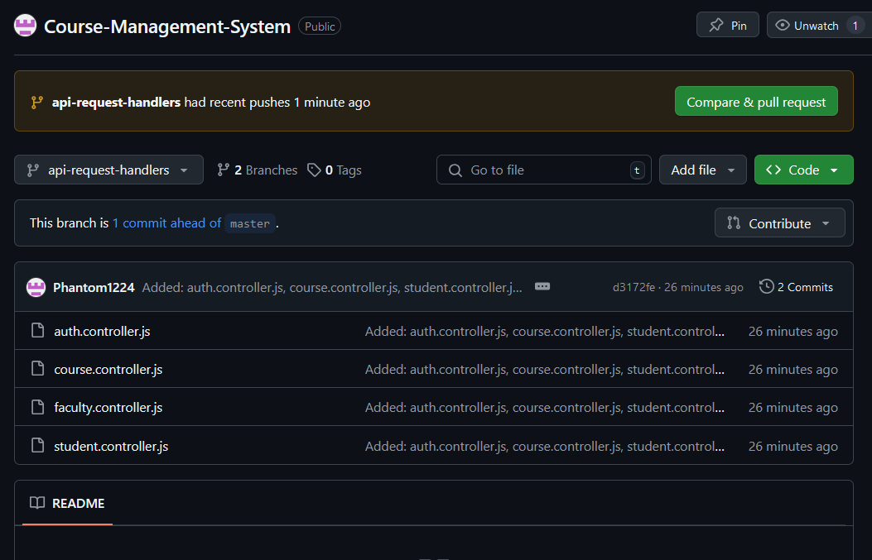

Finished configuration-files branch

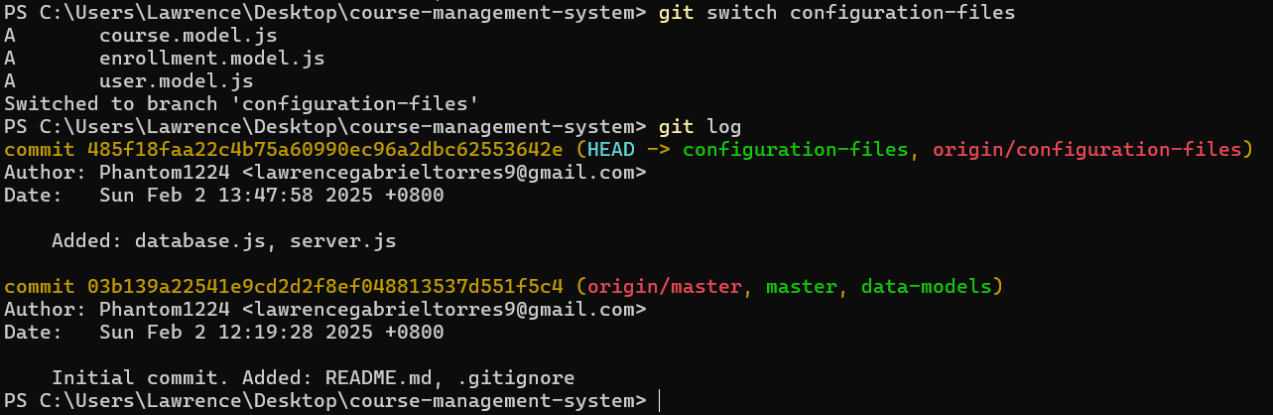

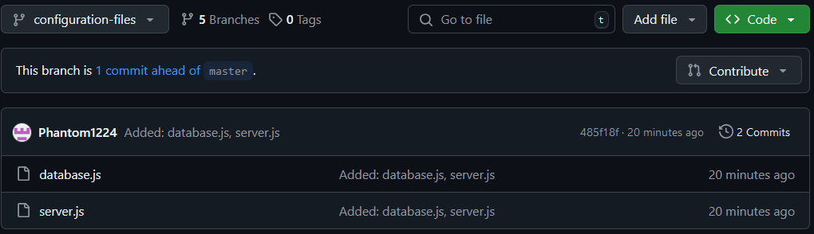

Finished data-models branch

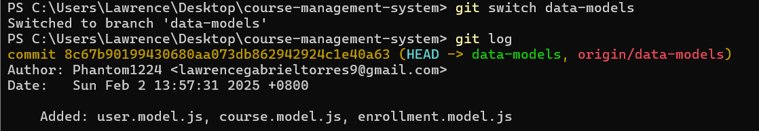

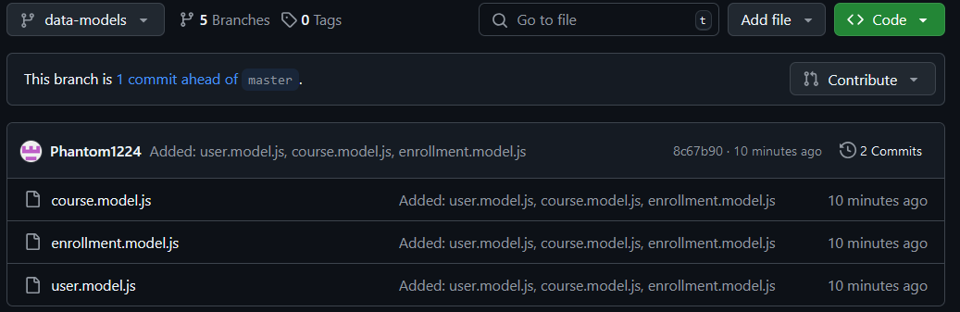

Finished business-logic branch

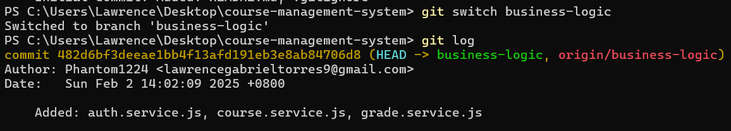

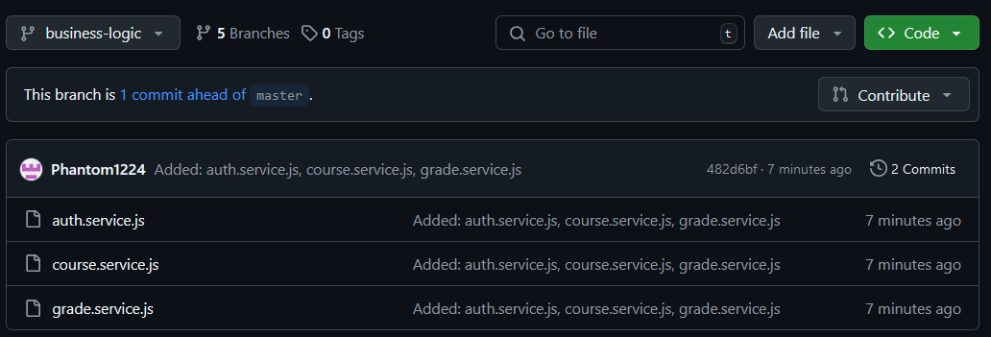

Finished project-requirements branch



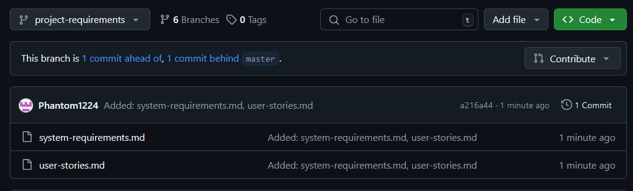

Finished api-custom-middleware branch

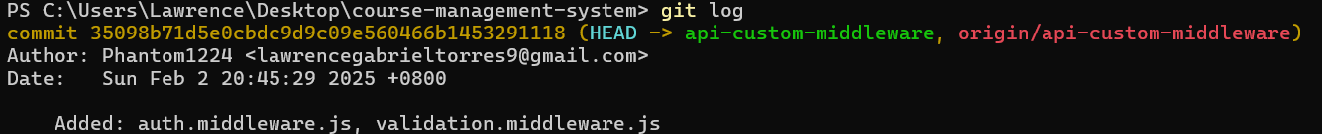

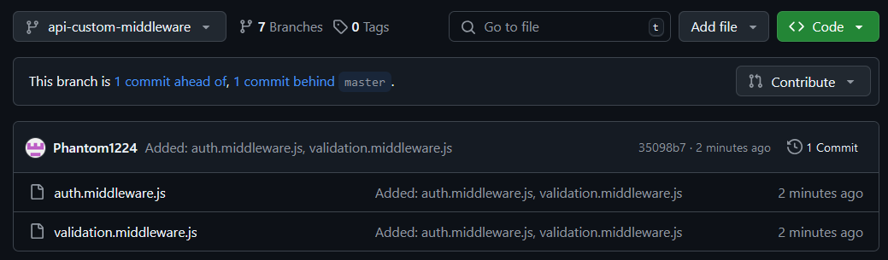

Finished api-routes branch

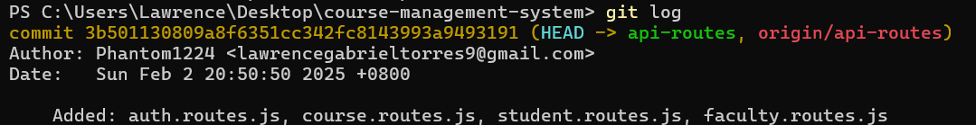

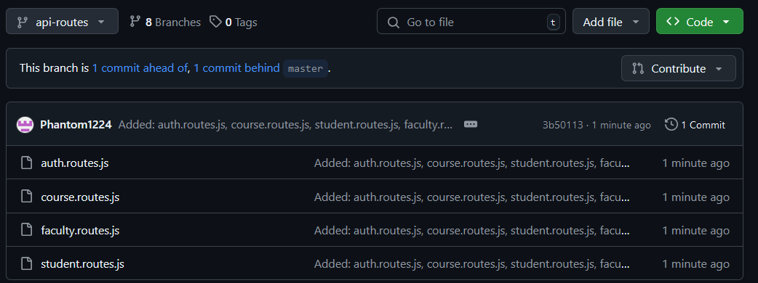

Finished api-request-validators branch

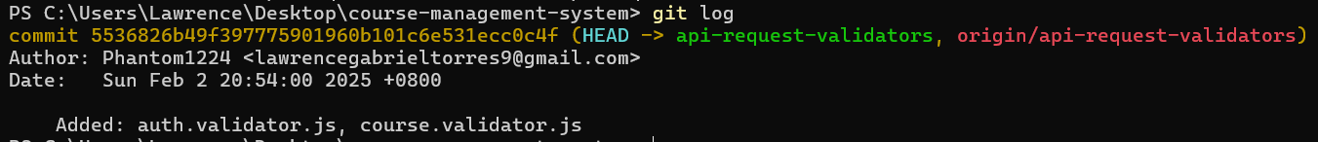

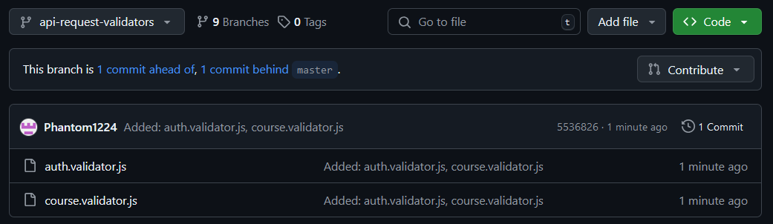

Finished utility-functions branch

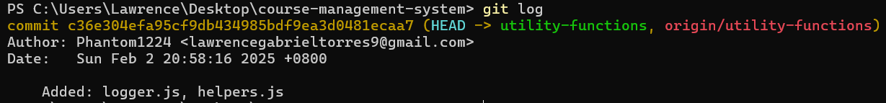

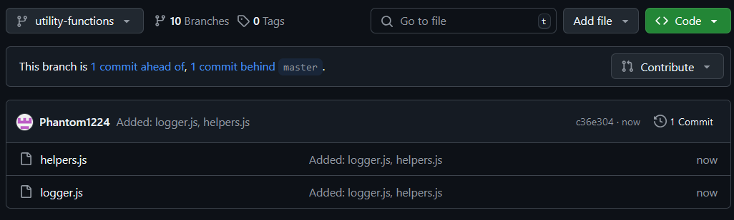

Finished setup-guides branch

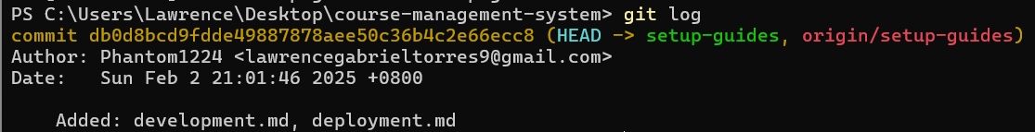

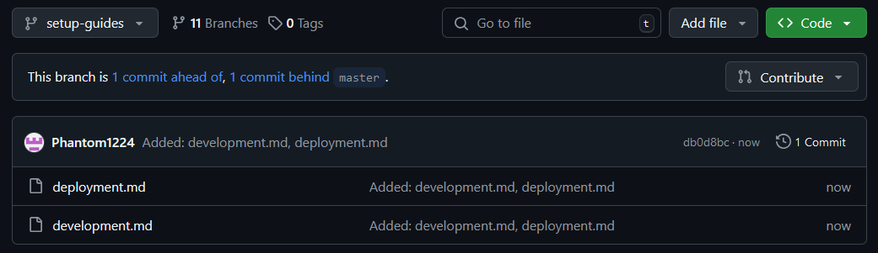

Finished project-guidelines branch

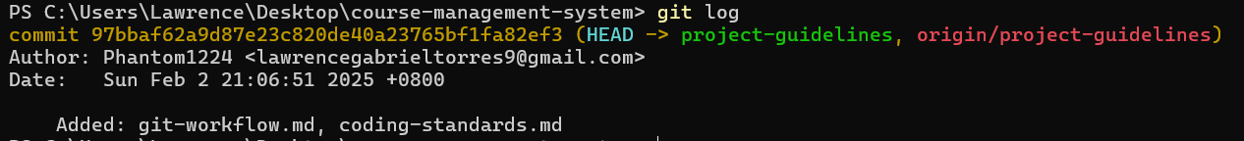

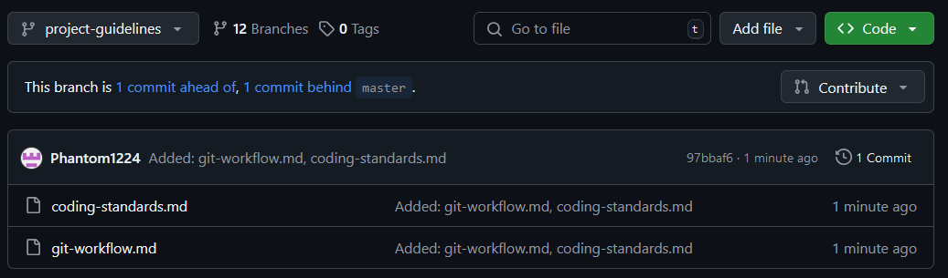

Made an experimental branch which merged all the preceding branches before it except the master branch

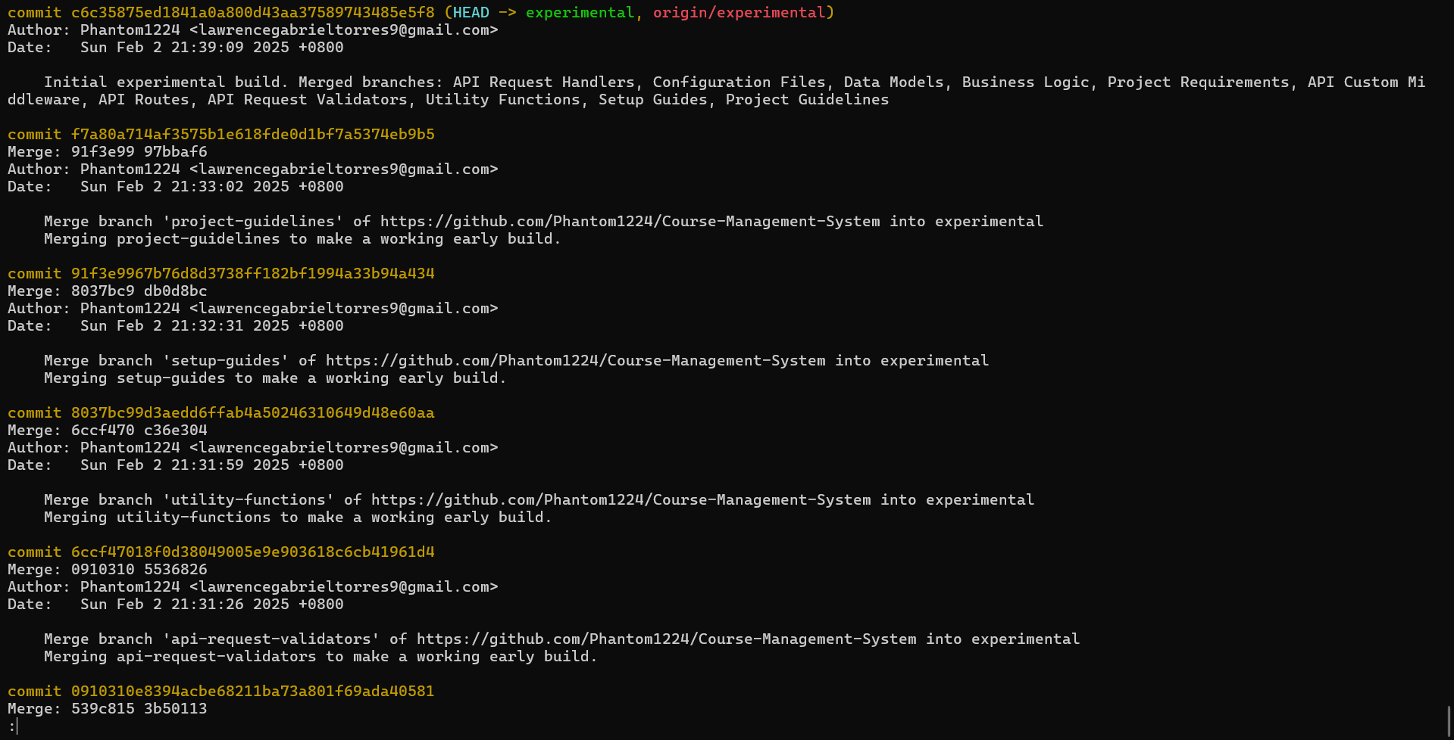

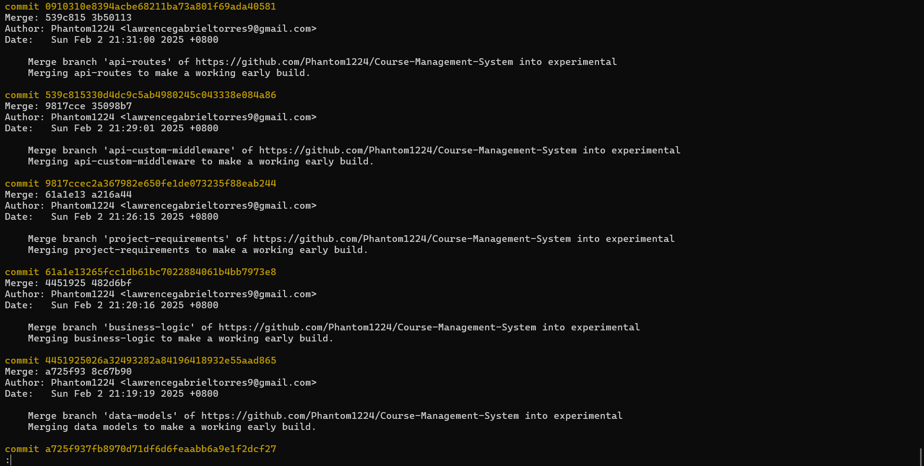

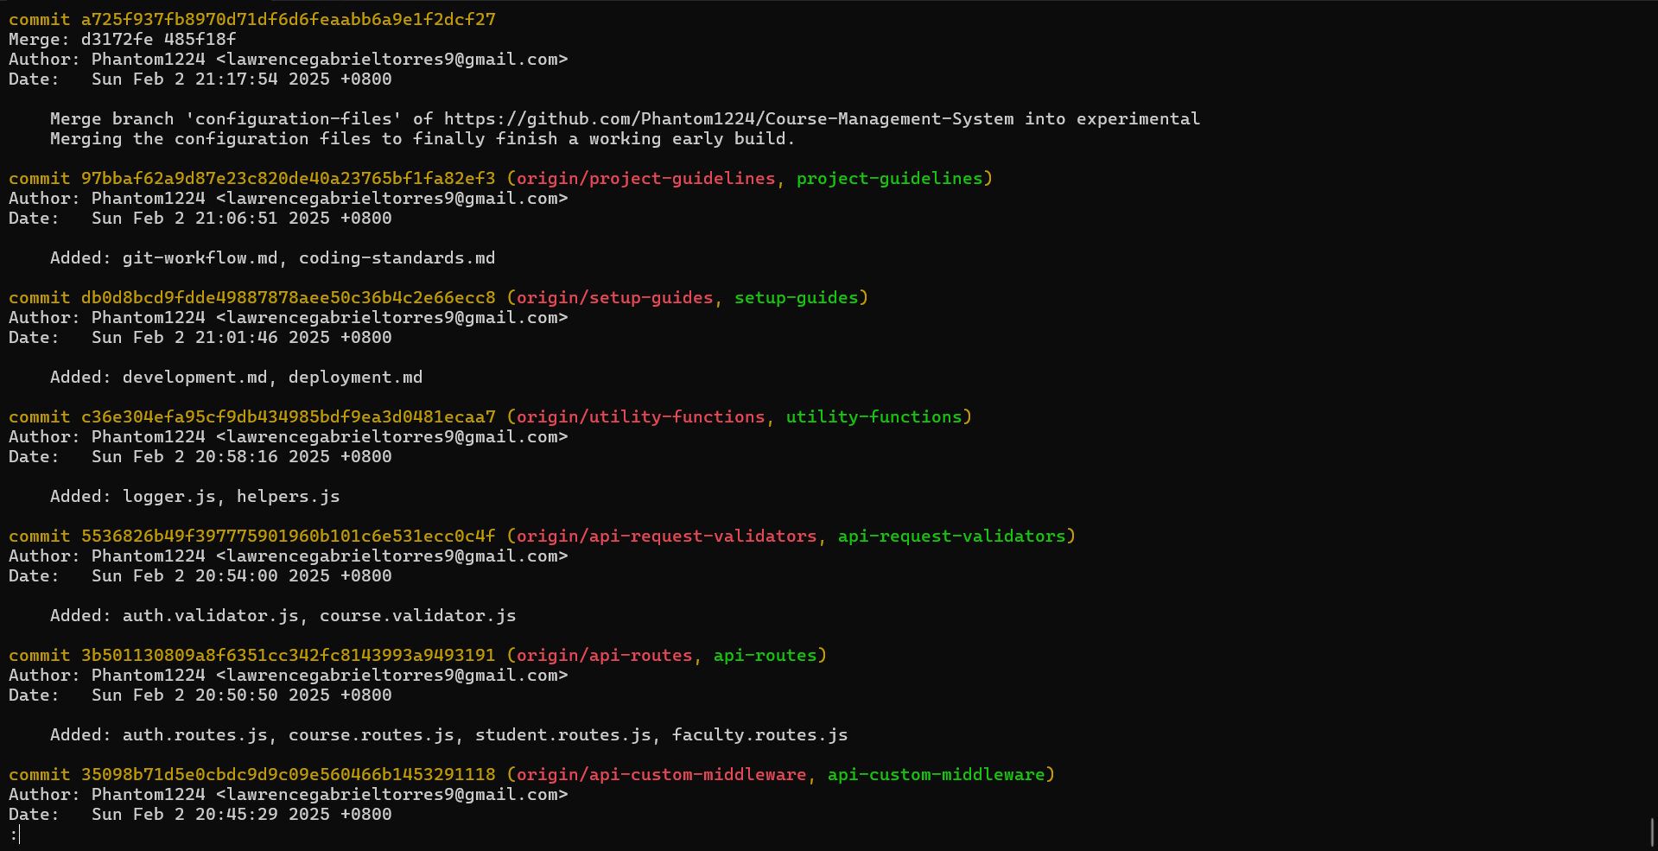

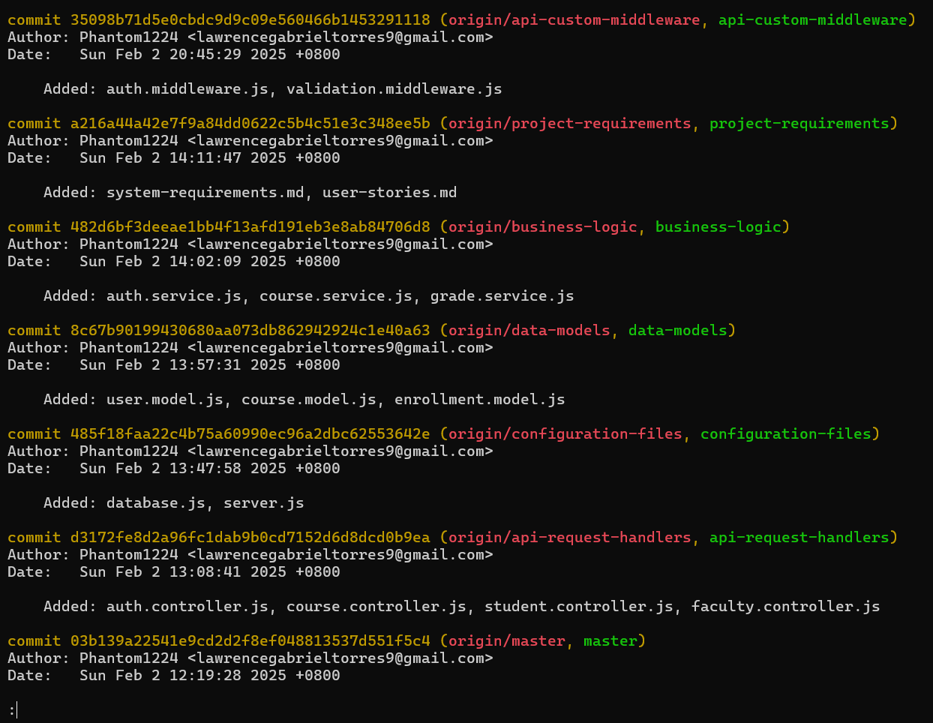

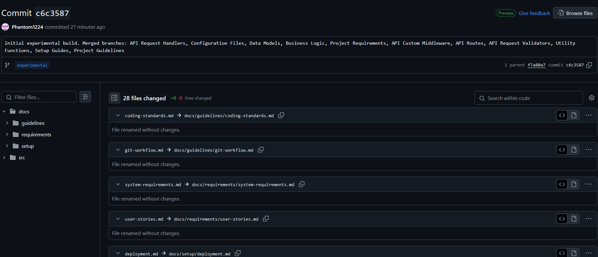

Finished unit-tests branch



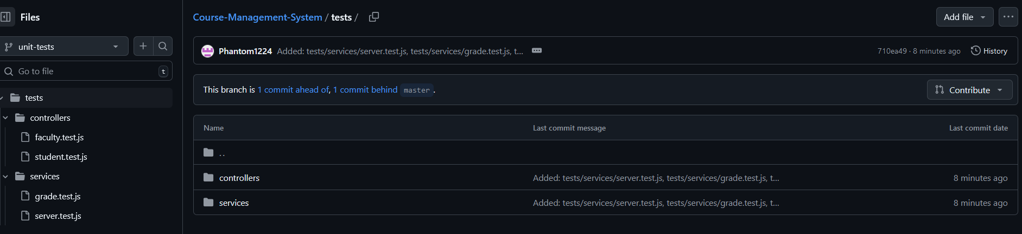

Merged unit-tests branch to experimental branch for feature testing

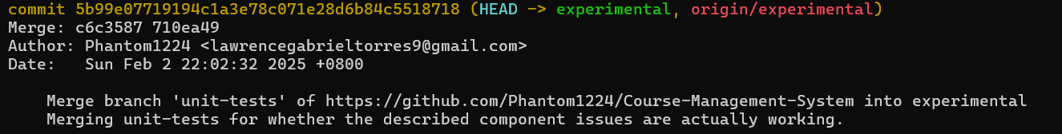

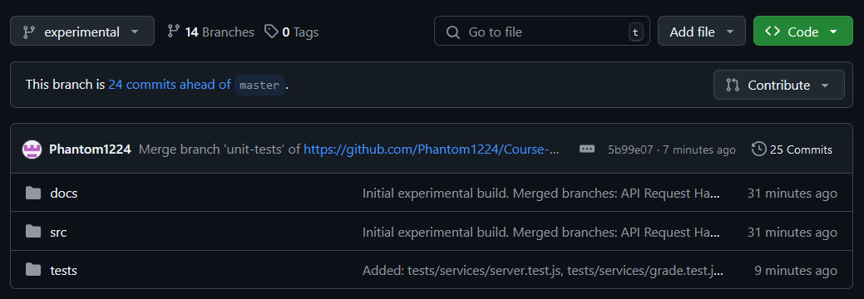

Added the following components to experimental branch:

* .env.example
* .eslintrc.js
* packages.json
* docker-compose.yml

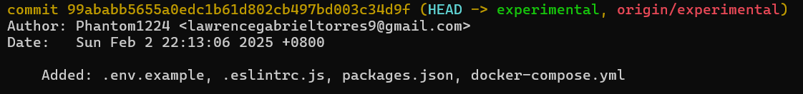

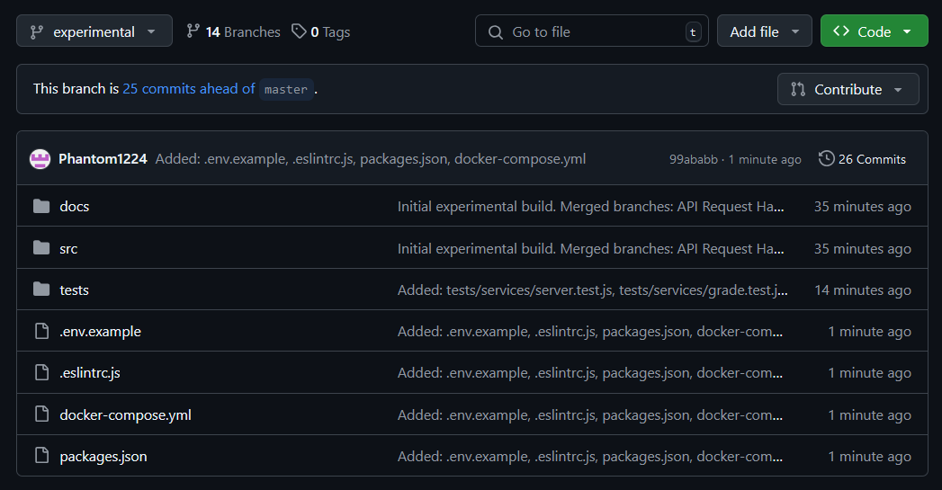

Finished integration-tests branch



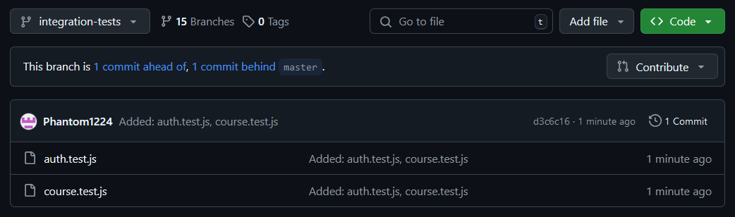

Changed location path of unit-tests



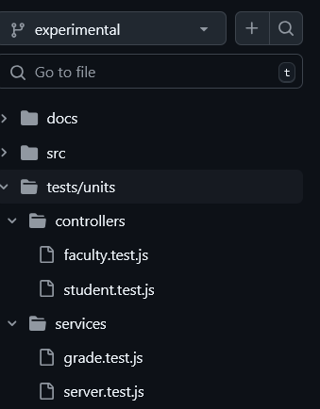

Merged integration-tests branch to experimental branch for sanity testing

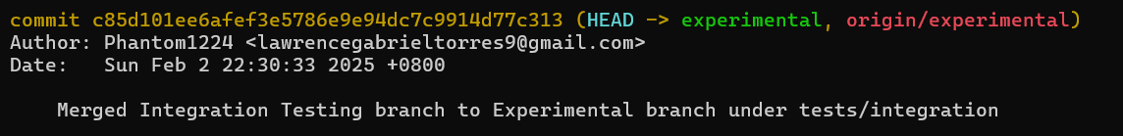

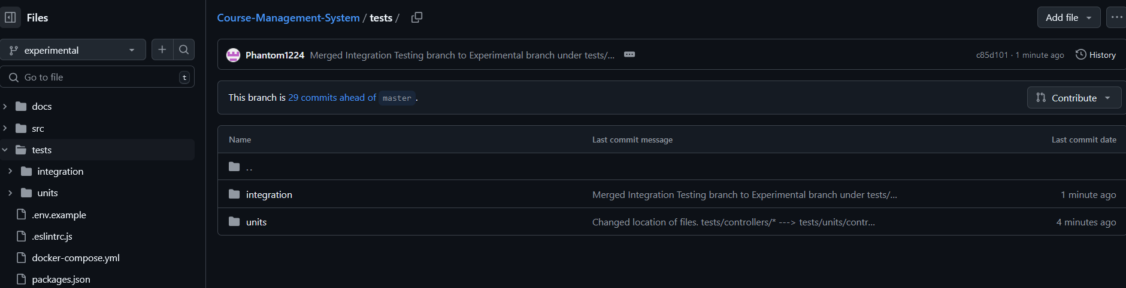

The whole experimental build seems to be complete and stable now. Now merging experimental build to the master build. Updated the README file which now has information about the software’s core features.



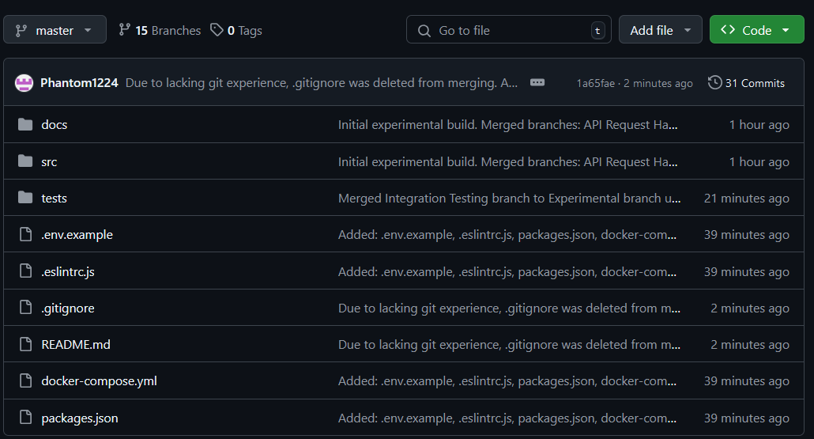

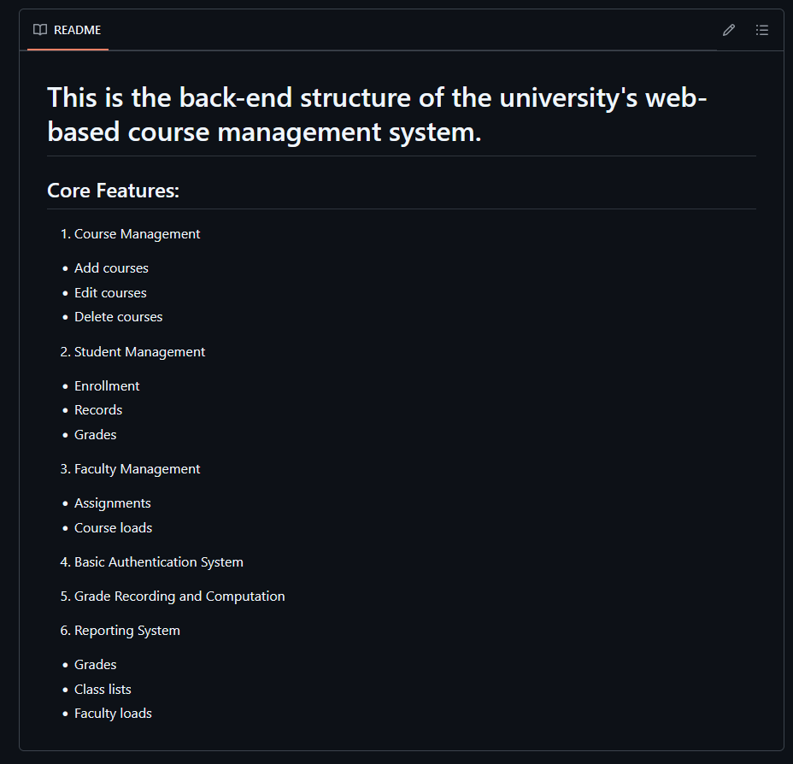

Updated the README file for the last time

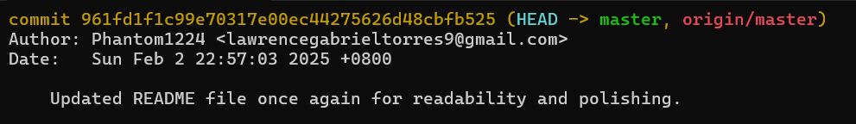

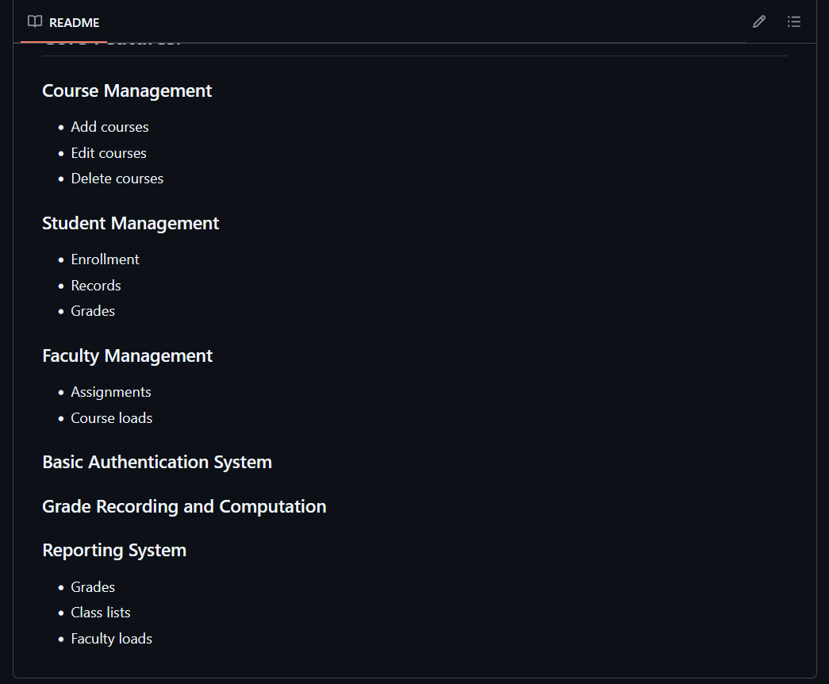

Documentation ends here. The file will now be included into the master branch.